1. 1Install Ruby
2. Download Ruby (<https://rubyinstaller.org/downloads/archives/>)

Ruby 2.5.0-2 (x64)



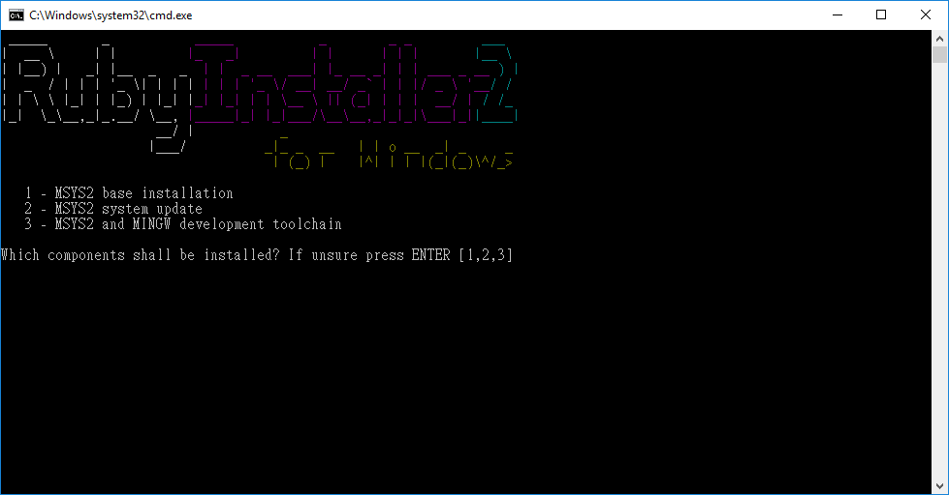

Respectively ENTER 1, 2, 3 and setup following the instruction

1. Verify Ruby installation. Open cmd, enter the command: *ruby –v*

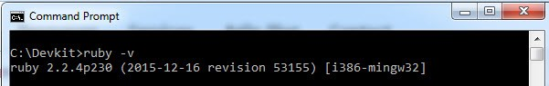

1. Verify RubyGems installation. Enter the command: *gem -v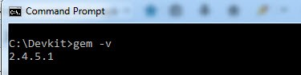*

Page Break

1. Enter the command: *gem install json*

Check the options:

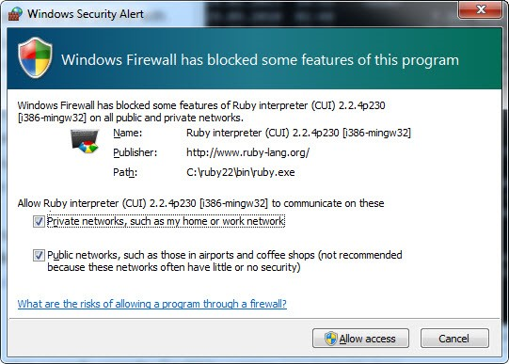

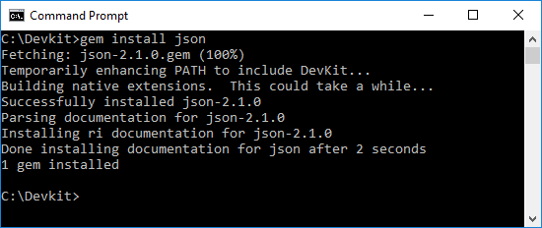

1. Install Webdriver
2. For Chrome:download Latest version [Chromedriver](https://sites.google.com/a/chromium.org/chromedriver/)

For Firefox:get geckodriver from shared folder

1. Create C:\webdriver directory

1. Extract and put chromedriver.exe into C:\webdriver

1. Go to Windows Settings > System > About > System info > Advanced system settings > Environment Variables…

Under System variables, select Path

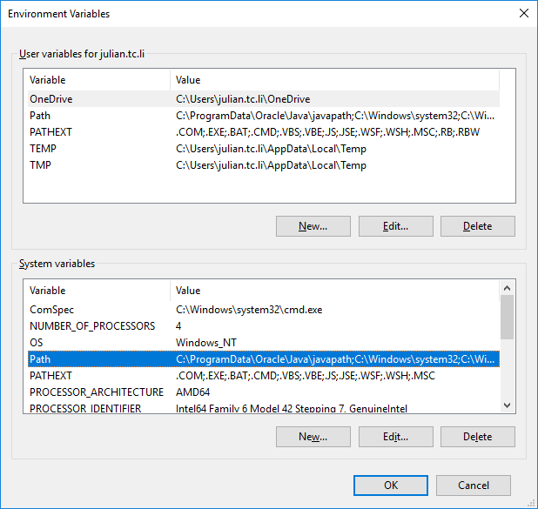

then click Edit…, click New and add C:\webdriver

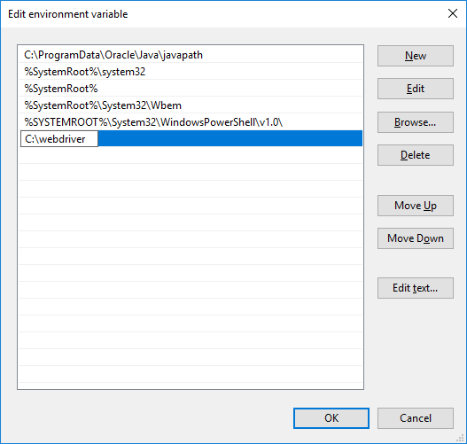

Page Break

1. Install [Chrome](https://www.google.com.hk/chrome/browser/desktop/index.html)

1. Download the project Ceevo_cucumber

1. Go to the project directory in cmd:

E.g. cd Desktop\Ceevo_cucumber

Enter the command: *gem install bundler*

Enter the command: *bundle install*

1. To run automation, open cmd and go to the project directory.
2. For running specific feature(s), enter:

>bundle exec cucumber “features\1. xxxx.feature” “features\2. xxxx.feature” …

1. For running all feature files, enter:

>bundle exec cucumber